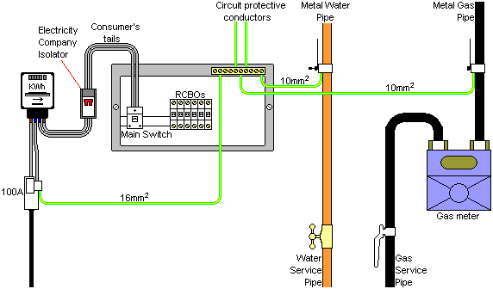

1. Main Isolator
2. Consumer Tails
3. Circuit Protective Conductor
4. Equipotential Bonding Conductor
5. Meter
6. Incoming service cut-out
7. Main Earthing Conductor

